Thomas Levitt

Professor Jaramillo

COP 4655

31 August 2023

<https://github.com/tlevitt2020/hw1_repo.git>

Step 0: Set up project

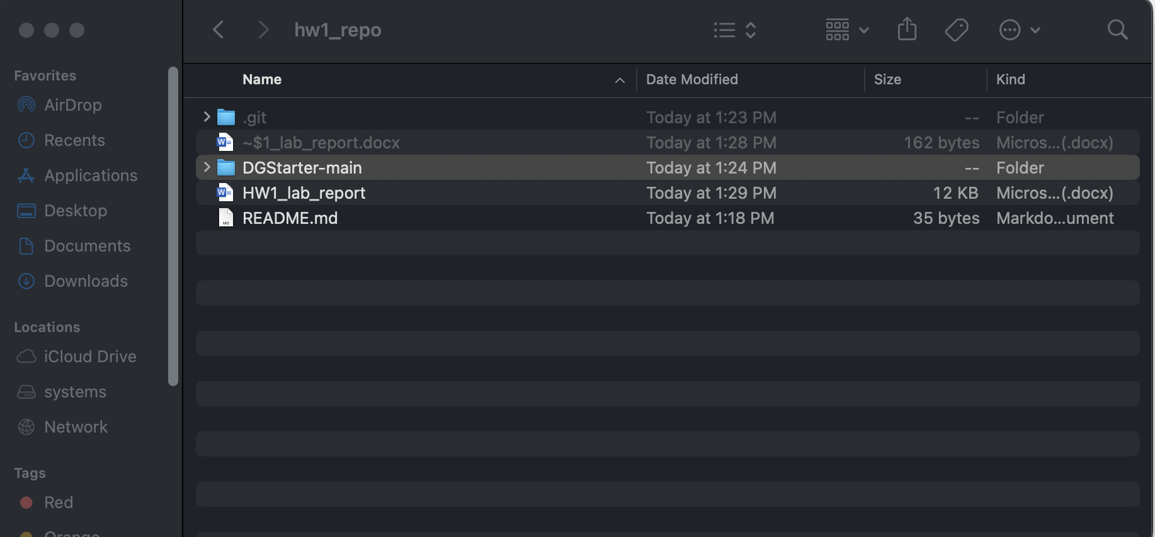

Step 1: Begin designing the layout of the first screen, GuesserViewController

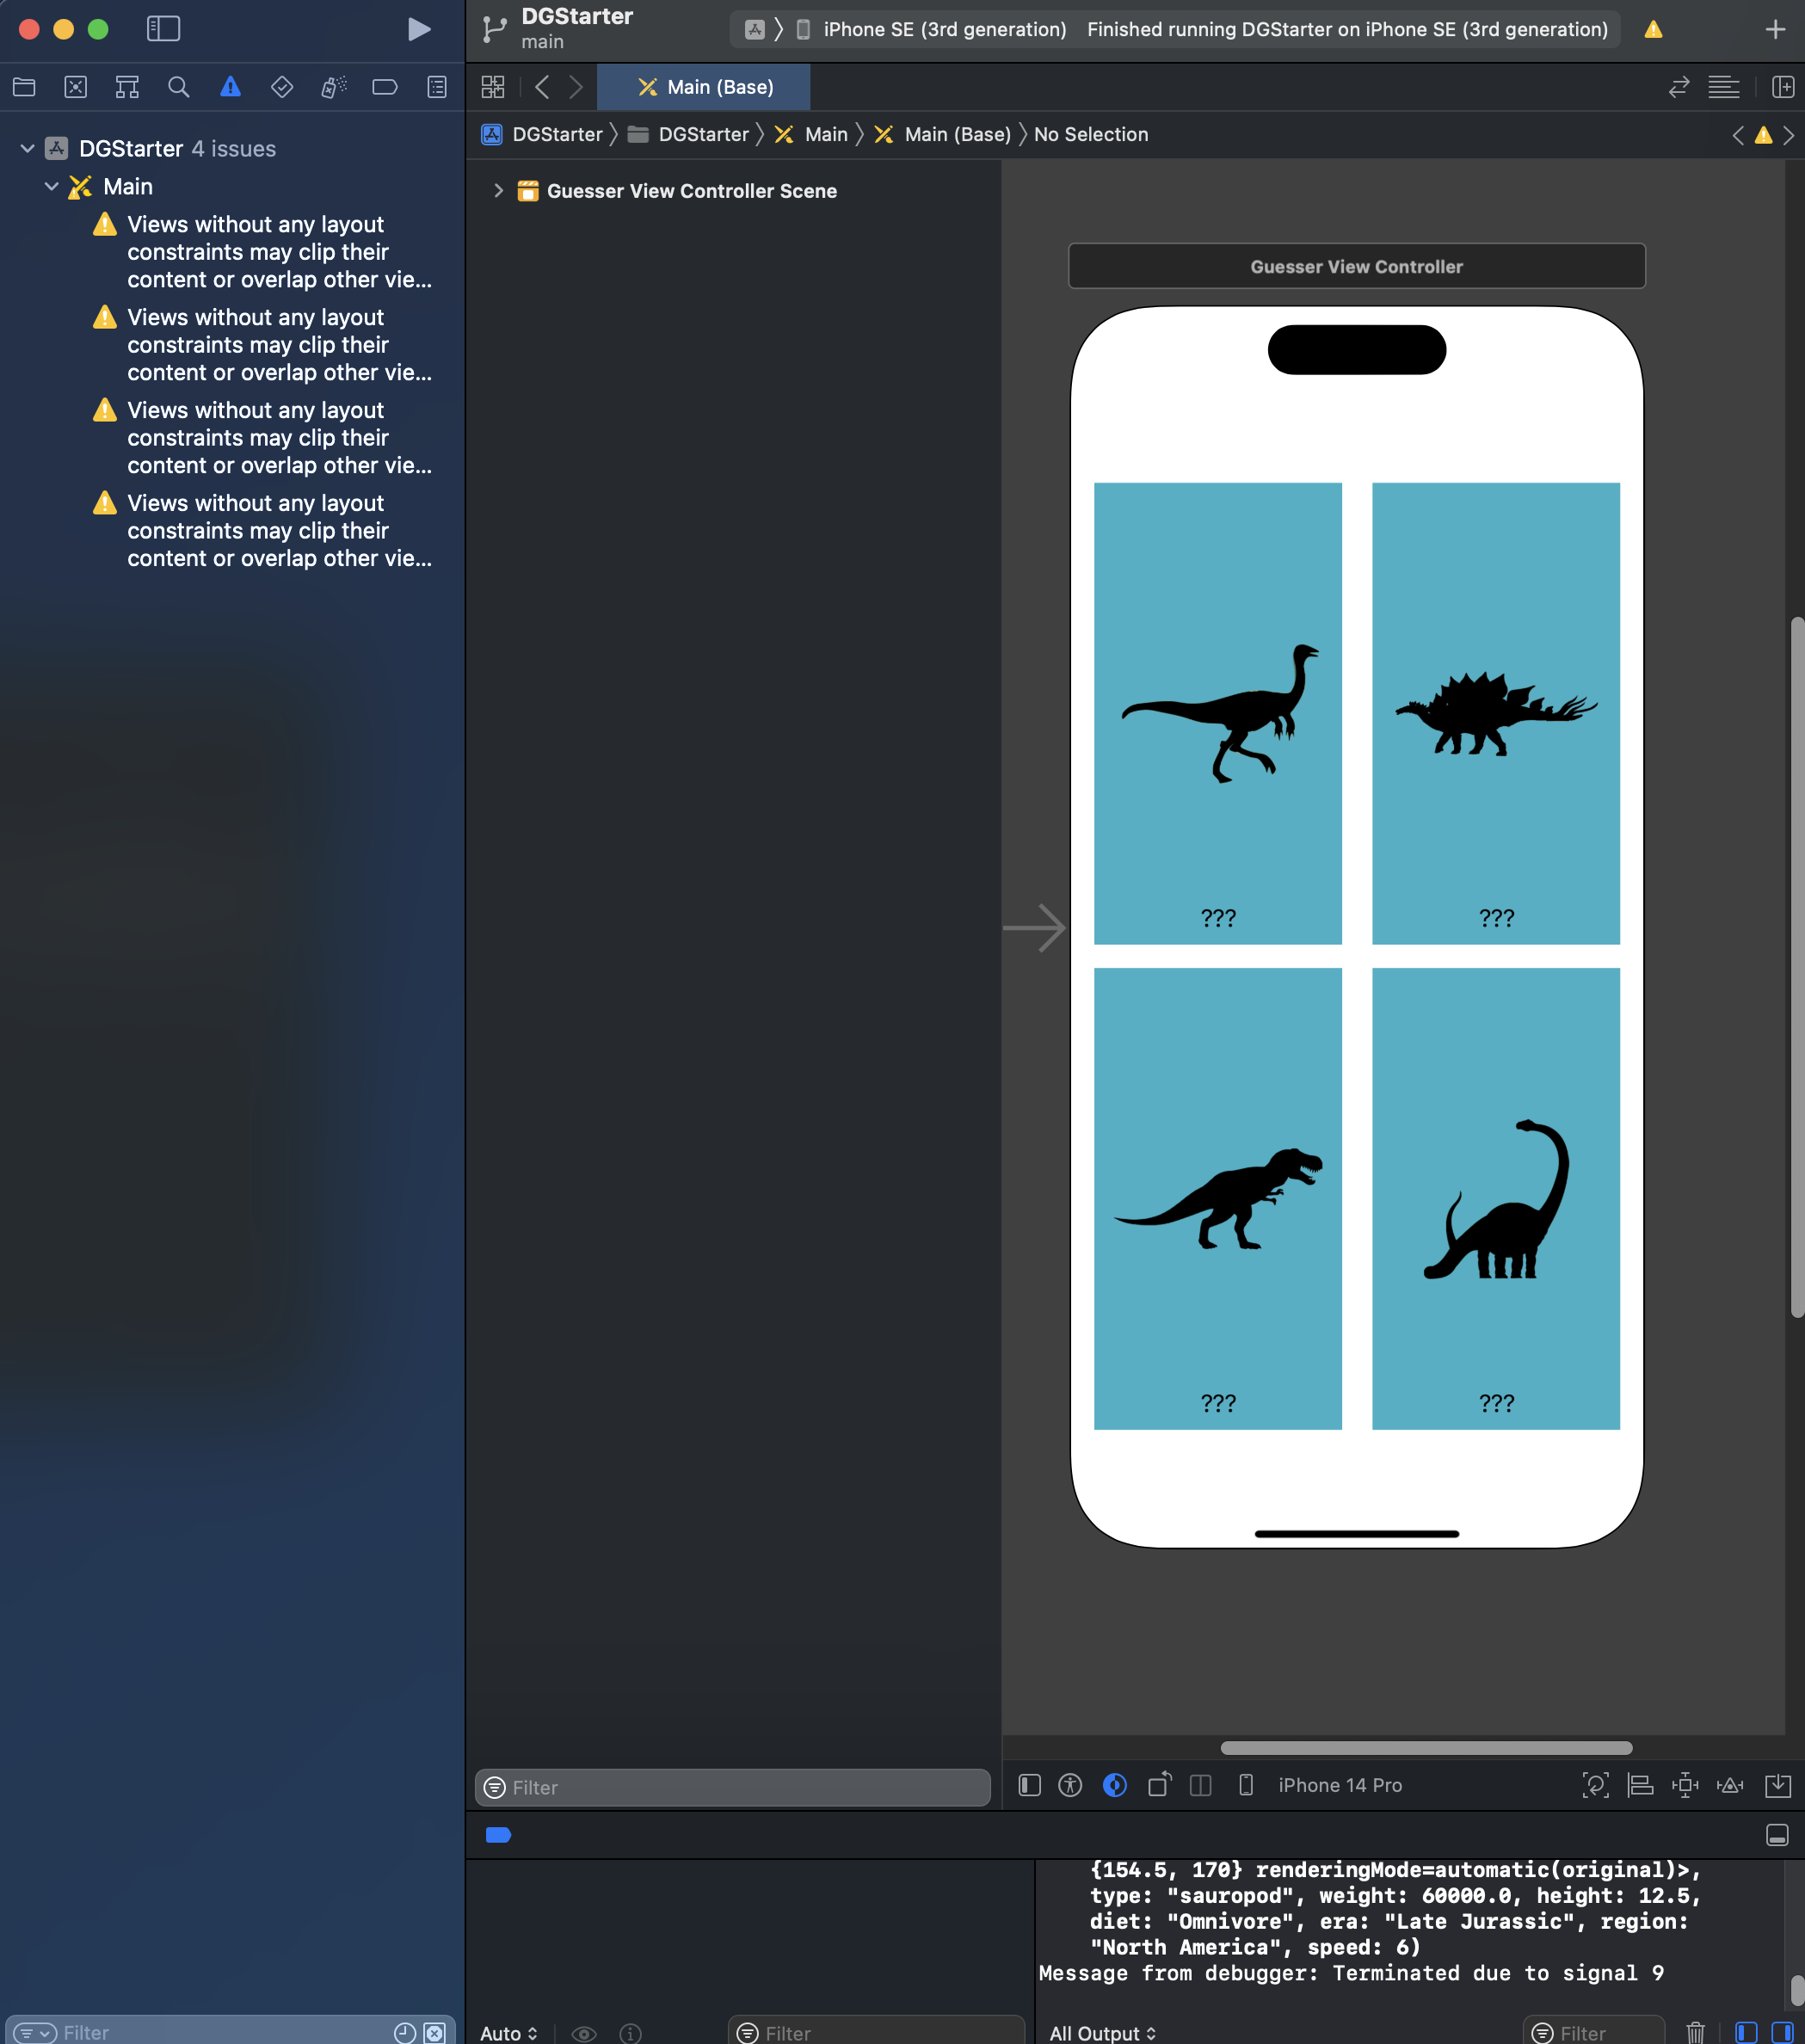

Step 2: Use Stack Views To Layout Guesser screen

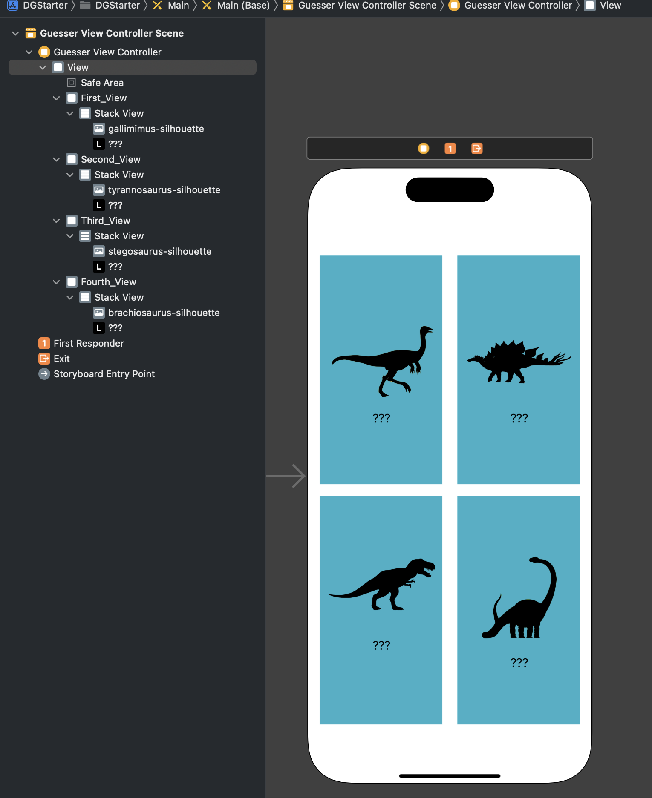

Step 3: Add Constraints and Configure Auto Layout in Guesser Screen

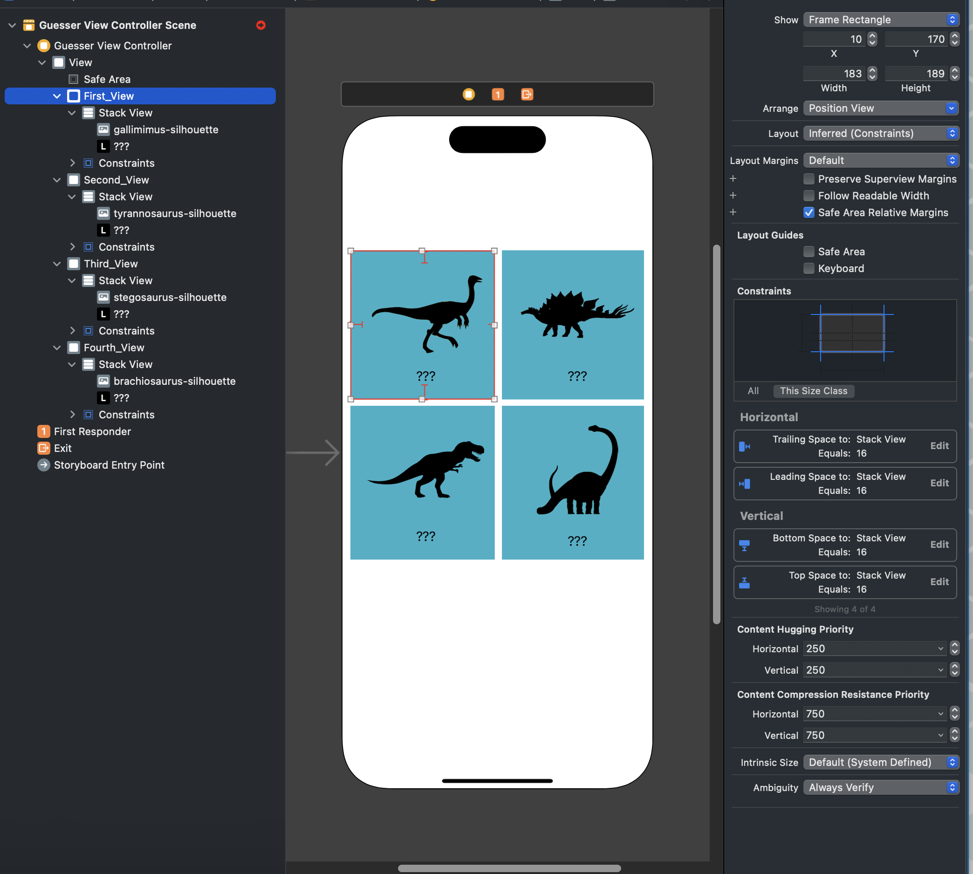

Step 4: Organizing the Stack Views

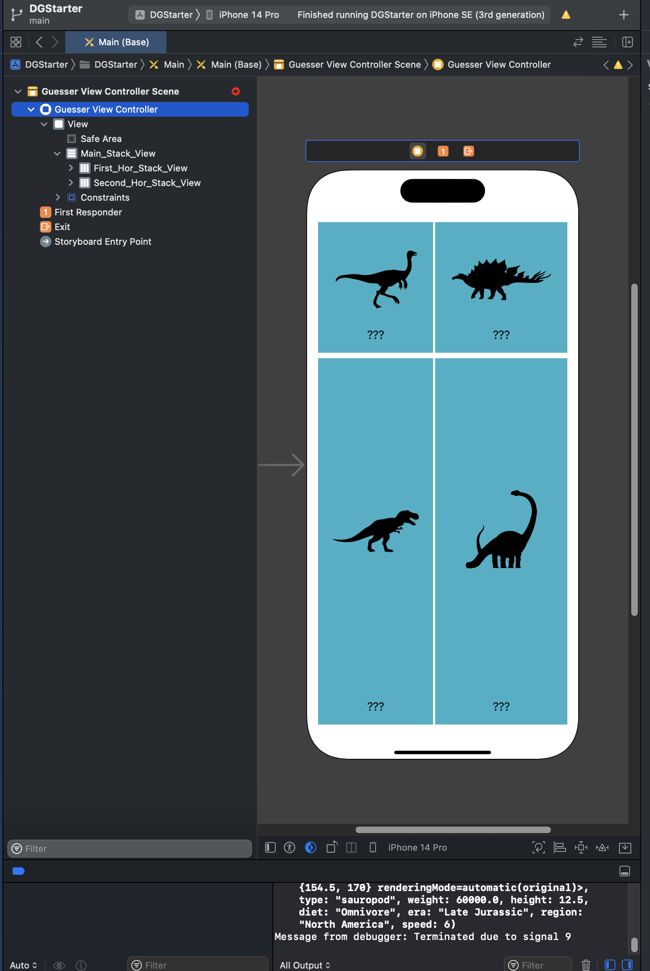

Step 5: Adjust the Content in the Guesser Screen

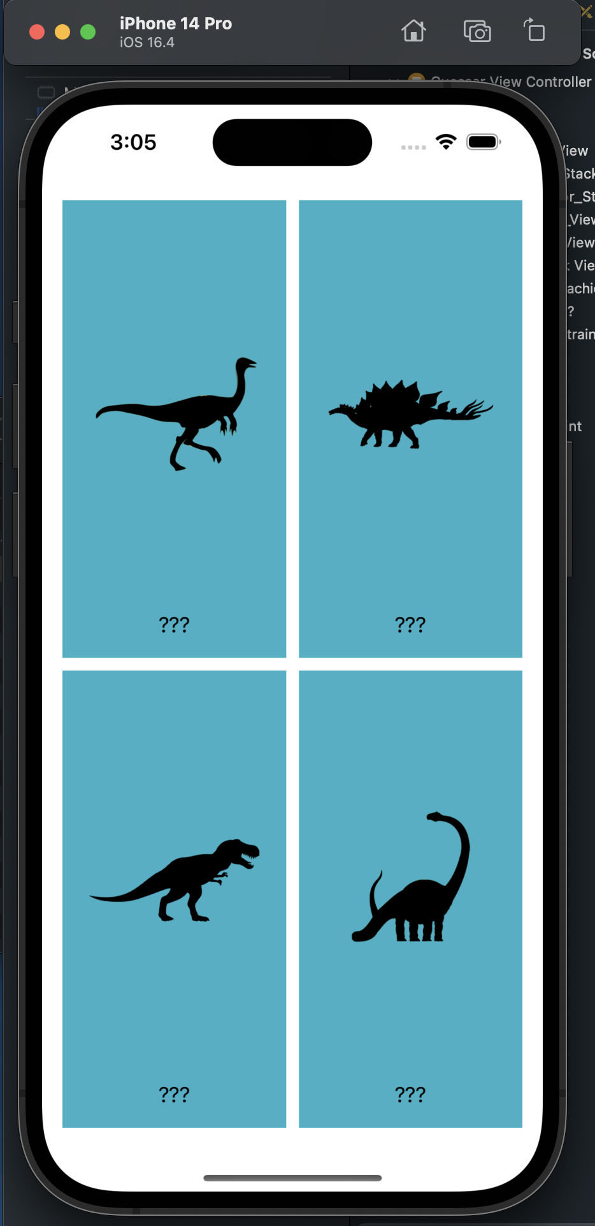

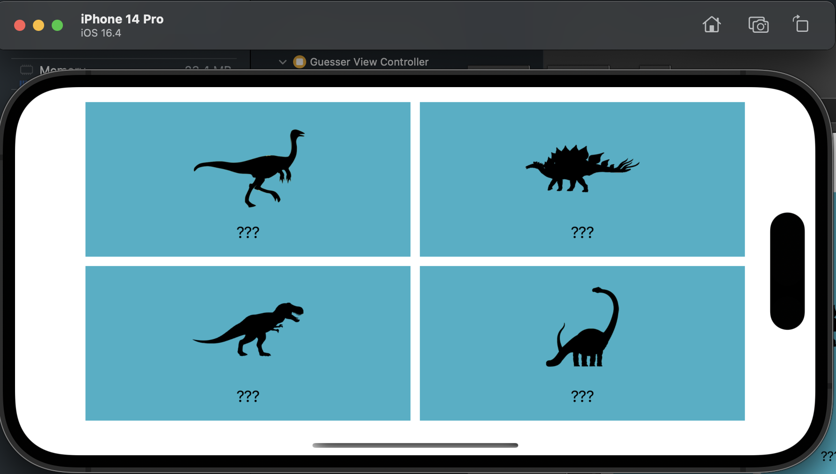

Step 6: Set up the Navigation Controller

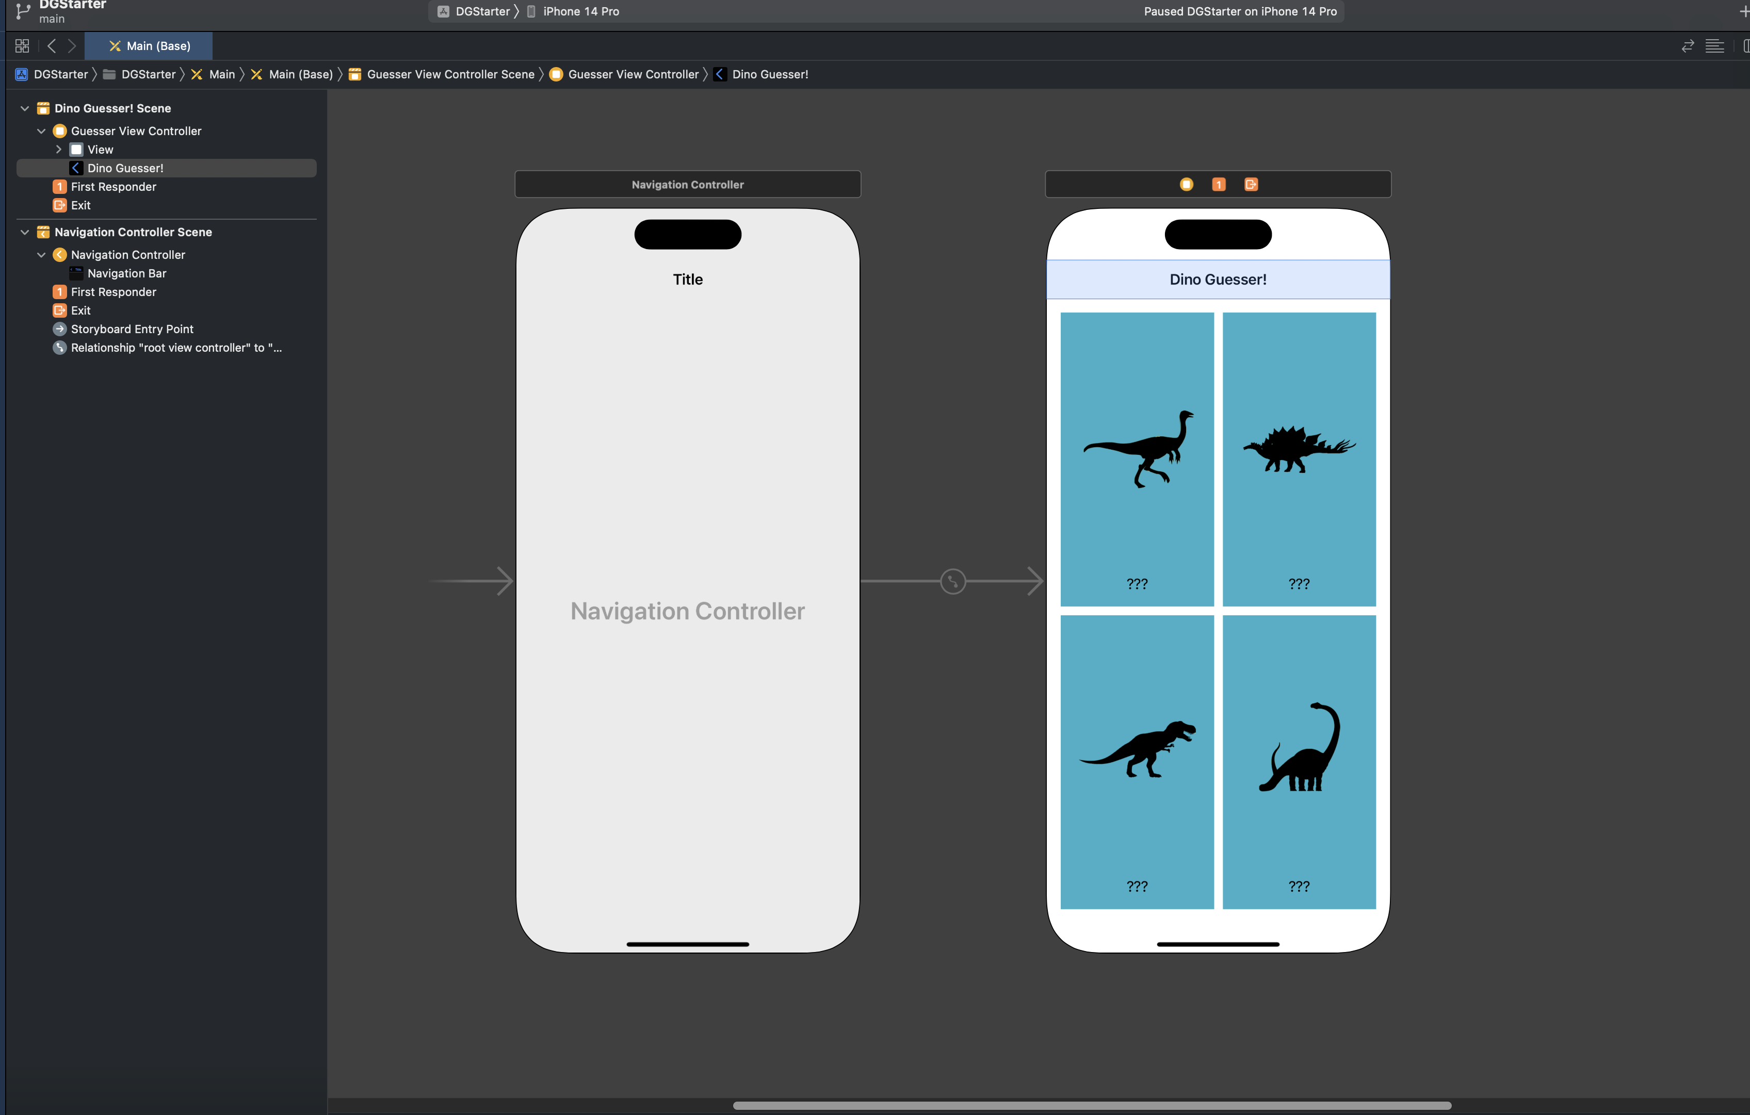

Step 7: Create the DetailViewController and Navigate to the Detail Screen

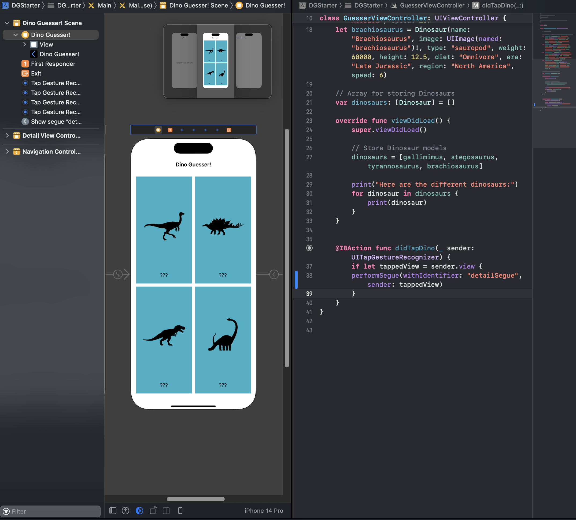

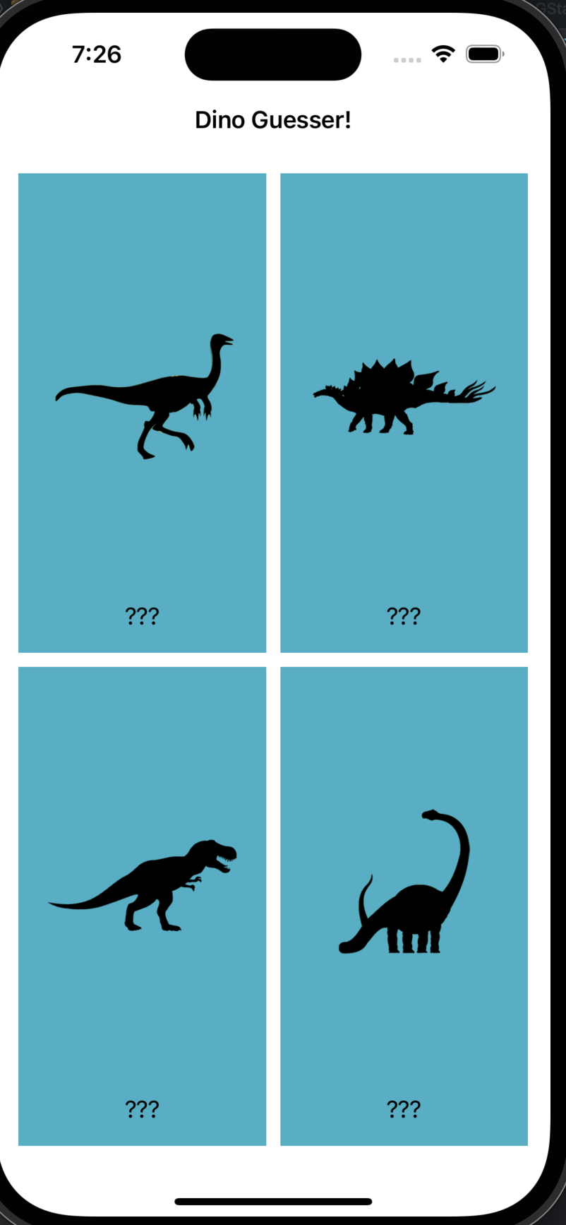

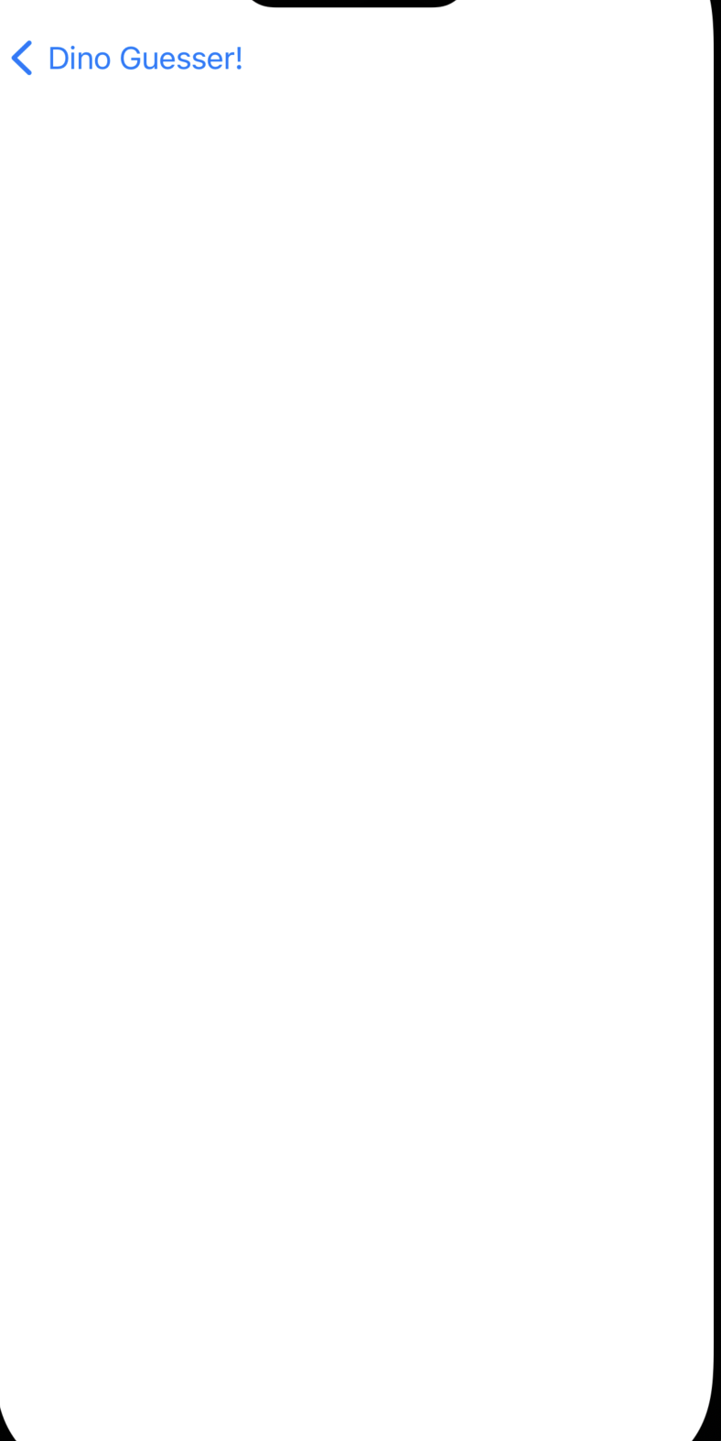

Step 8: Pass the Dinosaur Data to the DetailViewController

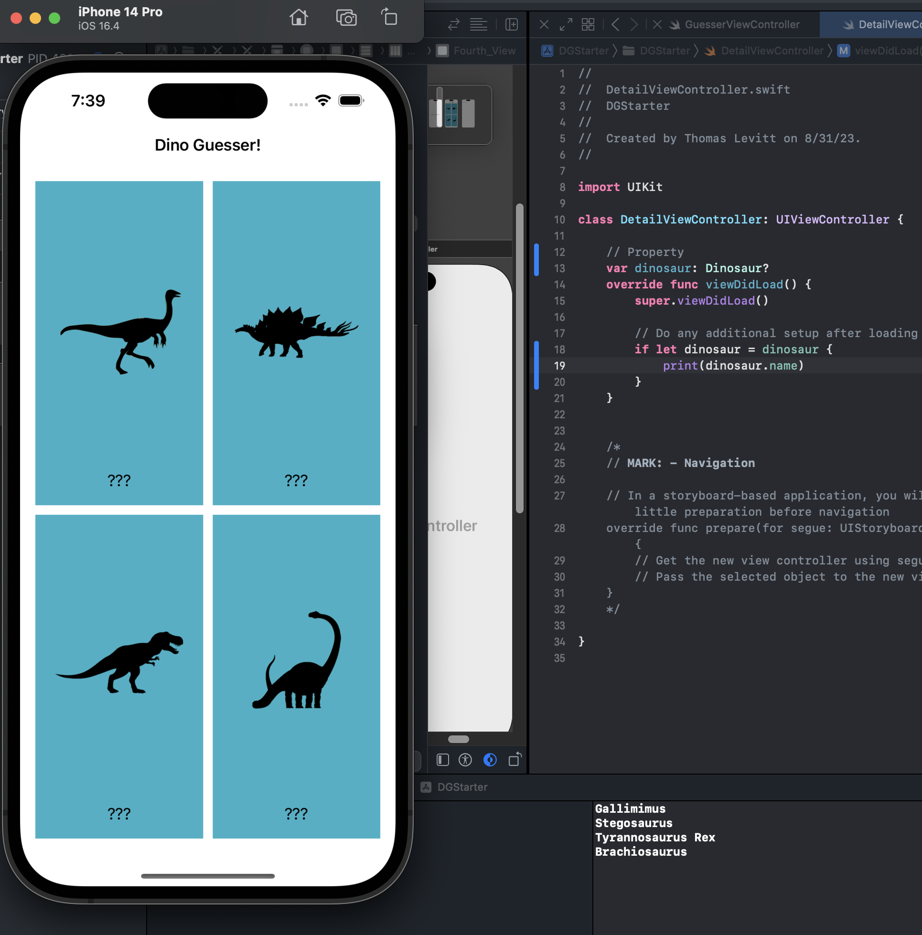

Step 9: Set up the UI for the DetailViewController